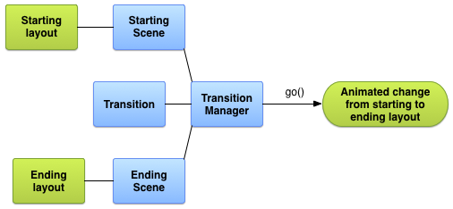

Class | Tag | Attributes | Effect
AutoTransition | <autoTransition/> | - | Default transition. Fade out, move and resize, and fade in views, in that order.
Fade | <fade/> | android:fadingMode="[fade_in |  fade_out |  fade_in_out]" | fade_in fades in views  fade_out fades out views  fade_in_out (default) does afade_out followed by afade_in.
ChangeBounds | <changeBounds/> | - | Moves and resizes views.

